k | Autumn 1 | Autumn 2 | Spring 1 | Spring 2 | Summer 1 | Summer 2
FOCUS | School routine  All about me  Autumn (outside) | Transport  Christmas  Winter (outside) | Animals from hot and cold countries | Planting, growth and change  Easter  Spring (outside) | Lifecycles | Seaside
I wonder questions | I wonder… what makes me, me? | I wonder… what journey I might go on? | I wonder…where animals come from? | I wonder…how things grow? | I wonder… how things change? | I wonder…what I will find?
Cultural capital | Our local area | Post office to post Christmas letters.  St Mary’s Church  Train ride | Bus trip to Dukinfield Library | Acresfield Gardens | Acresfield Gardens (pond) | Lytham
Author of the half term | Rebecca Cobb | June Crebbin | Jessica Souhami | Michael Rosen | Eric Carle | Atinuke
Texts | Hello friend  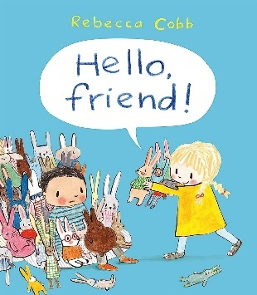 | The train ride | The leopards drum  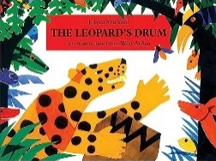  Blue Penguin | Errol’s garden | 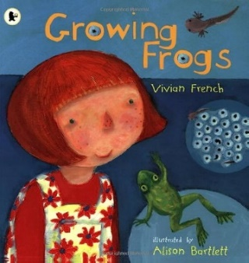  Growing frogs | Splash!  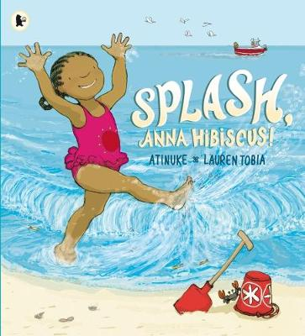
Communication and Language | Understand how to listen carefully and know why listening is important  Learn new vocabulary  Develop social phrases  Engage in story times  Learn rhymes and songs | Use new vocabulary throughout the day  Engage in non-fiction books  Listen carefully to rhymes and songs  Ask questions to find out more | Listen to and talk about selective non-fiction  Re-tell the story once they have developed a deep familiarity of the text | Describe events in some detail  Use talk to help work out problems and organise thinking and activities  Listen to and talk about stories to build familiarity and understanding | Articulate their ideas and thoughts in well-formed sentences  Connect one idea or action to another using a range of connectives | Express their ideas and feelings using full sentences  Offer explanations for why things might happen
Physical Development | Revise and refine the fundamental movement skills  Develop their small motor skills  Use their core muscle strength  Develop the skills they need to manage the school day successfully | Revise and refine the fundamental movement skills  Develop confidence, competence, precision, and accuracy when engaging in activities with a ball | Revise and refine the fundamental movement skills  Combine different movements with ease and fluency  Develop the overall body strength, balance and agility | Confidently and safely use a range of small and large apparatus  Further develop and refine a range of ball skills | Progress to a more fluent style of moving with developing control and grace | Hold a pencil effectively using the tripod grip
PSED | Manage their own needs  Build constructive and respectful relationships  Know and talk about different factors that support their overall health and wellbeing | Express their feelings and consider the feelings of others  Identify and moderate their own feelings socially and emotionally  See themselves as a valuable individual | Show resilience and perseverance in the face of challenge | Think about the perspective of others | Work and play cooperatively and take turns | Give focused attention to what the teacher says and following instructions involving several actions
Literacy (reading and Writing)  (See also RWI and CLPE Power of Reading planning) | Read individual letters by saying the sounds for them  Blend sounds into words so that they can read short words  Form lower case letters correctly | Read some letter groups which represent one sound and say some sounds | Read a few common exception words matched to the school’s phonics programme  Spell words by identifying the sounds and then writing the sounds with letters | Read simple phrases and sentences made up of words with known letter sounds correspondences  Re-read books to build up their confidence in word reading, fluency and understanding | Write short sentences with words with known sound letter correspondences using a capital letter and a full stop  Re-read what they have written to check that it makes sense | Retell a story in your own words  To know RWI set 1 and set 2 sounds
Mathematics (See mastering number plan)
RE (See separate SACRE planning) | Which people are special and why? | Which stories are special and why? | Which places are special and why? | Which times are special and why? | Where do we belong? | What is special about our world?
Understanding the World | Talk about members of the immediate family and their community  Name a describe people who are familiar to them  Recognise that people have different beliefs  Exploring the natural world around them  Describe what the see, hear and feel outside | Draw information from a simple map  Understand the effect of changing seasons on the natural world around them | Recognise some similarities and differences between life in this country and other countries  Understand that some places are special to some members of their community  Recognise some environments that are different from the one they live in | Understand the effect of changing seasons on the natural world around them  Compare and contrast characters from stories including figures from the past  Plant seeds and care for growing plants. Identify 4 things that a plant needs to help it grow | Comment on images of familiar situations in the past  Understand the key features of a life cycle and identify 4 stages | Talk about the lives of the people around them and their roles in society  Explore the world making observations and drawing pictures of animals and plants
Expressive Arts and Design | Create collaboratively sharing ideas resources and skills.  Explore and engage in music making and dance | Explore and engage in music making and dance  Sing in a group or on their own | Develop story lines in their pretend play  Watch and talk about dance and performance art | Listen attentively, move to and talk about music, expressing their feelings and responses | Explore, use and refine a variety of artistic effects to express their ideas and feelings  Return to and build on their previous learning, refining ideas and developing their ability to represent them | Explain the process and how they have done something  Invent and create own stories

