 | Autumn 1 | Autumn 2 | Spring 1 | Spring 2 | Summer 1 | Summer 2
FOCUS | School routine  All about me  Autumn (outside) | Transport  Christmas  Winter (outside) | Animals from hot and cold countries | Planting, growth and change  Easter  Spring (outside) | Lifecycles | Seaside  Summer (outside)
I wonder questions | I wonder… what makes me, me? | I wonder… what journey I might go on? | I wonder…where animals come from? | I wonder…how things grow? | I wonder… how things change? | I wonder…what I will find?
Cultural Capital | Visits to local area | Post office to post Christmas letters.  St Mary’s Church  Bus trip to Dukinfield Library | Zoom link with Yorkshire Wildlife Park | Acresfield Gardens | Acresfield Gardens | Lytham
Author of the half term | Nick Sharratt | Michael Rosen | Eileen Brown | Caryl Hart | Eric Carle | Kes Grey
Texts | So much  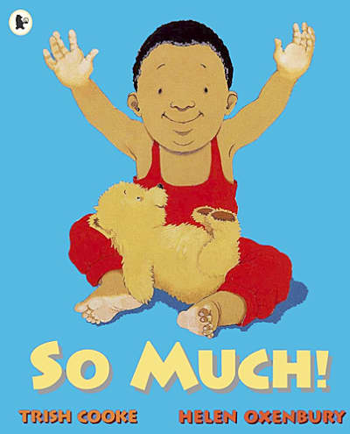 | Naughty bus  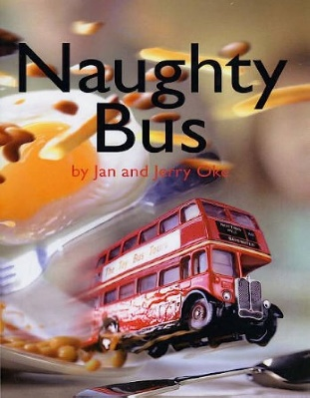 | Tanka, Tanka, Skunk!  Polar bear, polar bear  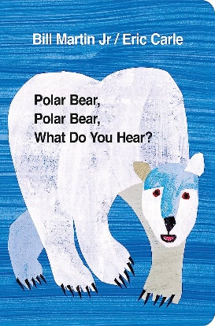 | 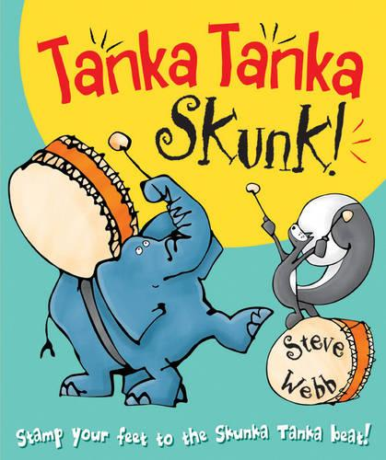  How to grow a dinosaur  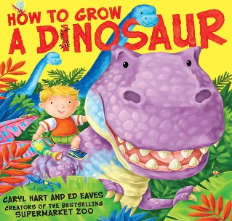 | Yucky worms  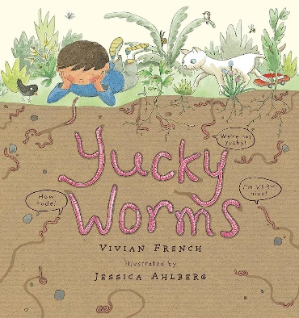 | Billy’s bucket  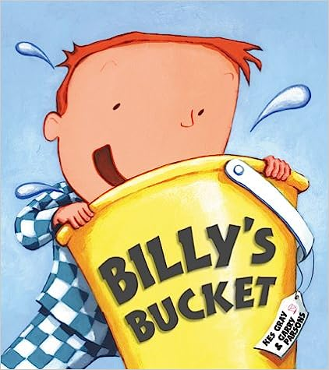
Communication and Language | Follow instructions  Attend and listen to a story  Use sentences with 4-6 words  Initiate a conversation and continue  Sing nursery rhymes | Follow instructions  Attend and listen to a story  Use sentences with 4-6 words  Initiate a conversation and continue  Sing nursery rhymes  Develop pronunciation | Pay attention to more than one thing at a time  Use talk to organise themselves and their play | Know many rhymes and be able to talk about familiar books | Develop their communication  Understand why questions | Be able to express a point of view and to debate when they disagree
Physical Development | Use large muscle movements  Be increasingly independent as they get dressed and undressed  Use one handed tools and equipment | Go up steps and stairs and climb up apparatus using alternate feet  Continue to develop their movement, balance, riding and ball skills  Collaborate with others to manage large items | Skip, hop and stand on one leg and hold a pose  Choose the right resources to carry out their own plan | Increasingly be able to use and remember sequences and patterns of movements  Start taking part in group activities | Match their developing physical skills to tasks and abilities | Use a comfortable grip with good control  Show a preference for a dominant hand
PSED | Remember rules  Play with one or more children  Talk about their feelings  Being increasingly independent about meeting their own needs | Select and use activities and resources  Remember rules  Play with one or more children  Understand how others may be feeling | Become more outgoing with unfamiliar people  Make healthy choices about food and drink | Develop a sense of responsibility and membership of a community  Show more confidence in new social situations | Develop appropriate ways of being assertive  Talk with others to solve conflicts | Find solutions to conflicts and rivalries
Literacy (reading and Writing) | Understand the 5 concepts about print | Understand the 5 concepts about print | Develop their phonological awareness | Develop their phonological awareness  Use print and letter knowledge in early writing  Extend in extended conversations about stories | Develop their phonological awareness  Use print and letter knowledge in early writing | Develop their phonological awareness  Write some or all of their name  Write some letters accurately
Mathematics | Recite numbers past 5  Understand position through words alone  Begin to describe a sequence of events | Say 1 number for each item in order  Describe a familiar route  Discuss routes and locations | Show finger numbers up to 5  Compare quantities using language  Select shapes appropriately  Extend and create ABAB patterns | Combine shapes to make new ones  Make comparisons between objects  Talk about and identify the patterns around them  Notice and correct an error in a repeating pattern | Talk about and explore 2d and 3d shapes  Subitise to 3 | Subitise to 5  Link numerals and amounts  The carinal principle to 5  Experiment with symbols and numerals
Understanding the World | Talk about what they see using a wide vocabulary  Being to make sense of their own life story and their families history  Begin to understand the need to respect and care for the natural environment and living things | Talk about the differences between materials and changes they notice  Continue developing positive attitudes about the differences between people  Show interest in different occupations | Know that there are different countries in the world  Use all their senses in hands on exploration of natural materials | Plant seeds and care for growing plants  Understand the key features of a life cycle | Begin to develop complex stories using small world equipment | Explore and talk about different forces
Expressive Arts and Design | Explore colour and colour mixing  Listen with increased attention to sounds  Remember and sing entire songs | Take part in simple pretend play  Explore different materials freely  Join different materials and explore different textures | Create closed shapes with continuous lines  Play instruments with increasing control to express their feelings  Sing the pitch of a tone sung by another person | Develop their own ideas and decide which materials to use  Respond to what they have heard | Draw with increasing complexity  Sing the melodic shape of familiar songs | Show different emotions in their drawings  Use drawing to represent their ideas  Create their own songs

